Mentorship Project

Hello World-Mars Hybrid Application on AWS using Terraform

Contents

Project Objectives: 2

Notes for week of Mar 2 to Mar 9 2

Notes for week of Feb 23 to Mar 1 2

Terraform Configuration Files 6

Technical Diagrams 6

# Project Objectives:

1. Create a Hello, World application and deploy it in AWS using Terraform
2. Present the solution and demonstrate how it relates to current job and RBC infrastructure footprint
3. Focus on Security and cover aspects of IAM, encryption, network segmentation, etc.

## Notes for week of Mar 2 to Mar 9

* First draft design completed in technical diagrams section covering:
  + Only the ALB should be in the public subnet
  + Hybrid environment – imitate on-prem and cloud environment
  + Create a second VPC and establish VPN connectivity
  + Create a bastion host in the second and talk to private subnets via VPN and SSH
  + Create a self-hosted VPN for the developers and DBA, and admins
  + Consider data flow diagrams
* The application should use the database – In progress
* Terraform configuration files – In Progress
* ID management – define roles and permissions in the code for developers, DBA and admins – In Progress

## Notes for week of Feb 23 to Mar 1

1. Learning how AWS and Terraform work
2. Udemy course
3. Single server deployment reading articles on medium

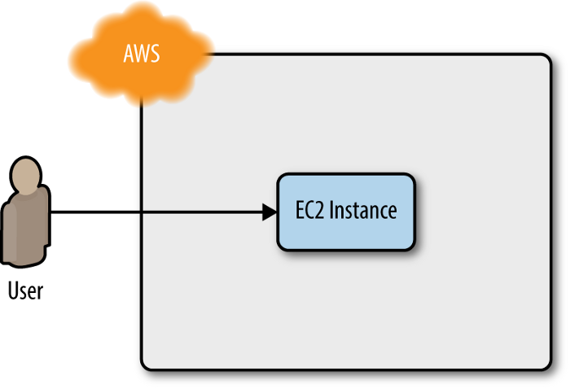

1. Played around with Auto-scaling groups. Possible area of expansion for scalability

The project

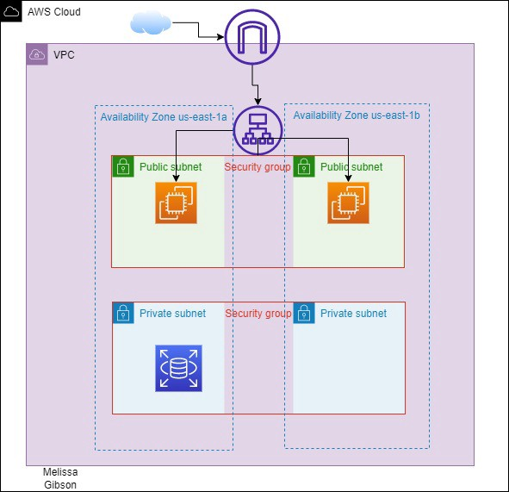

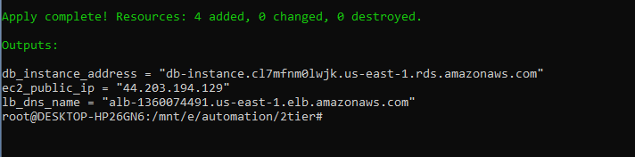

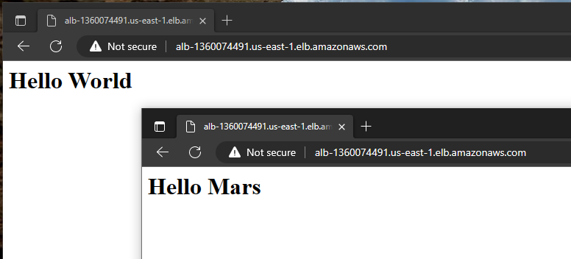

EC2

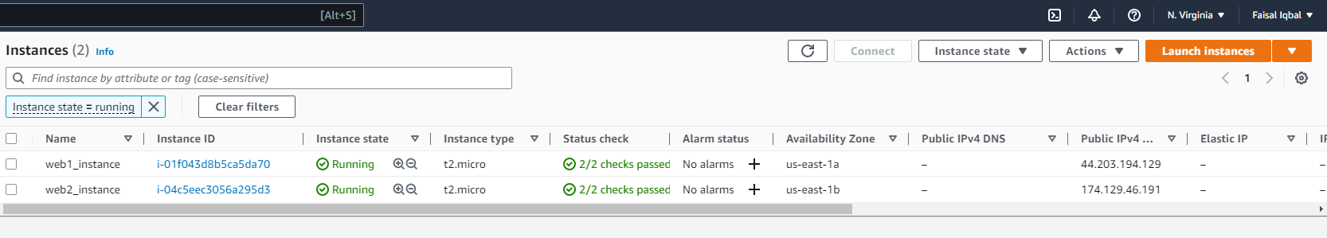

VPC

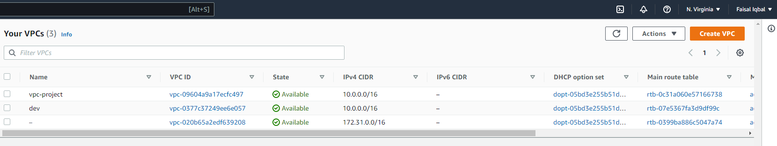

Subnets

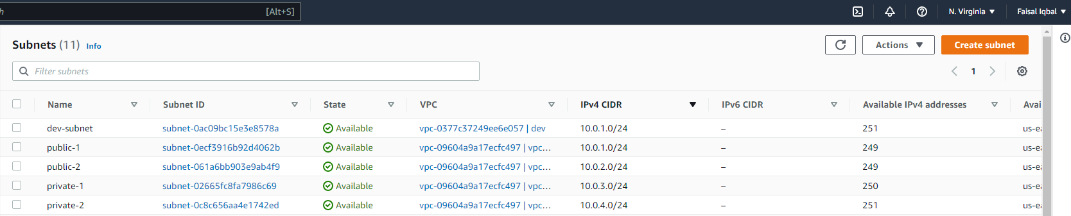

ALB sending traffic to 2 targets

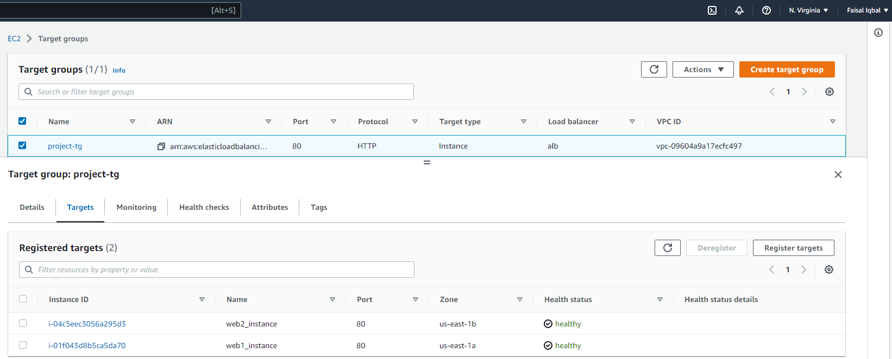

terraform init

terraform validate

terraform plan

terraform apply

terraform destroy

Questions:

* 1. Firewalls, requirements for
  2. Load balancer – round robin
  3. What kind of application is it? what kind of data to store

## Terraform Configuration Files

Configuration Files are available on Github Public Project: [iqbal-faisal788/terraform_hello_world (github.com)](https://github.com/iqbal-faisal788/terraform_hello_world)

## Technical Diagrams

